THESIS

EFFECT OF CALCINATION AND SINTERING TEMPERATURES ON THE STRUCTURAL AND MECHANICAL PROPERTIES OF PVA- HYDROXYAPATITE BIOCERAMICS DERIVED FROM DUCK AND CHICKEN EGGSHELLS



By:

AYUNDA WULAN PERMATASARI

NPM: 22037010001

PHYSICS STUDY PROGRAM FACULTY OF ENGINEERING AND SCIENCE
UNIVERSITAS PEMBANGUNAN NASIONAL “VETERAN”
JAWA TIMUR SURABAYA 2026

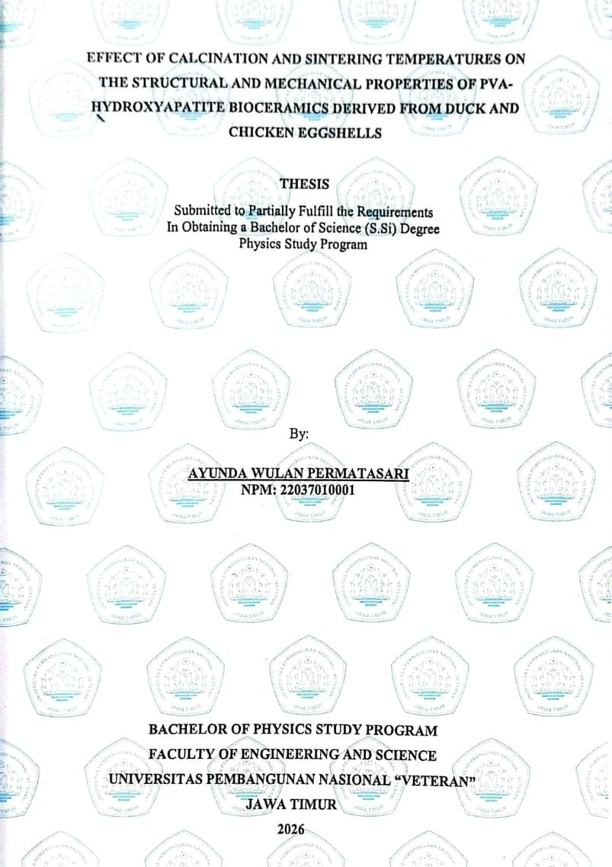

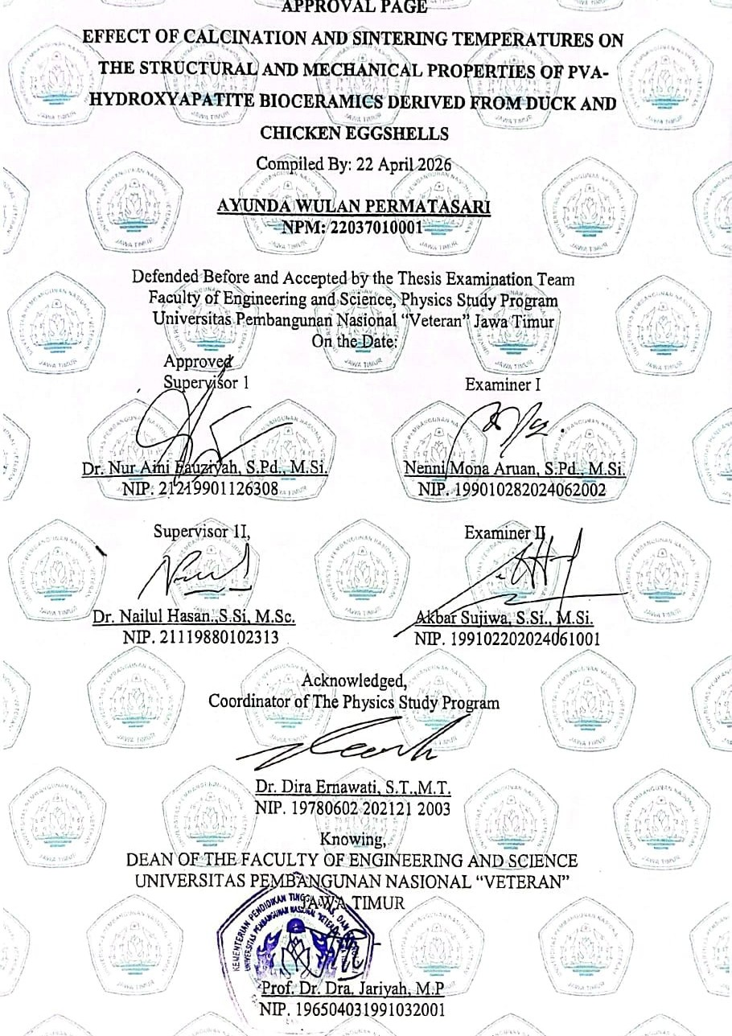

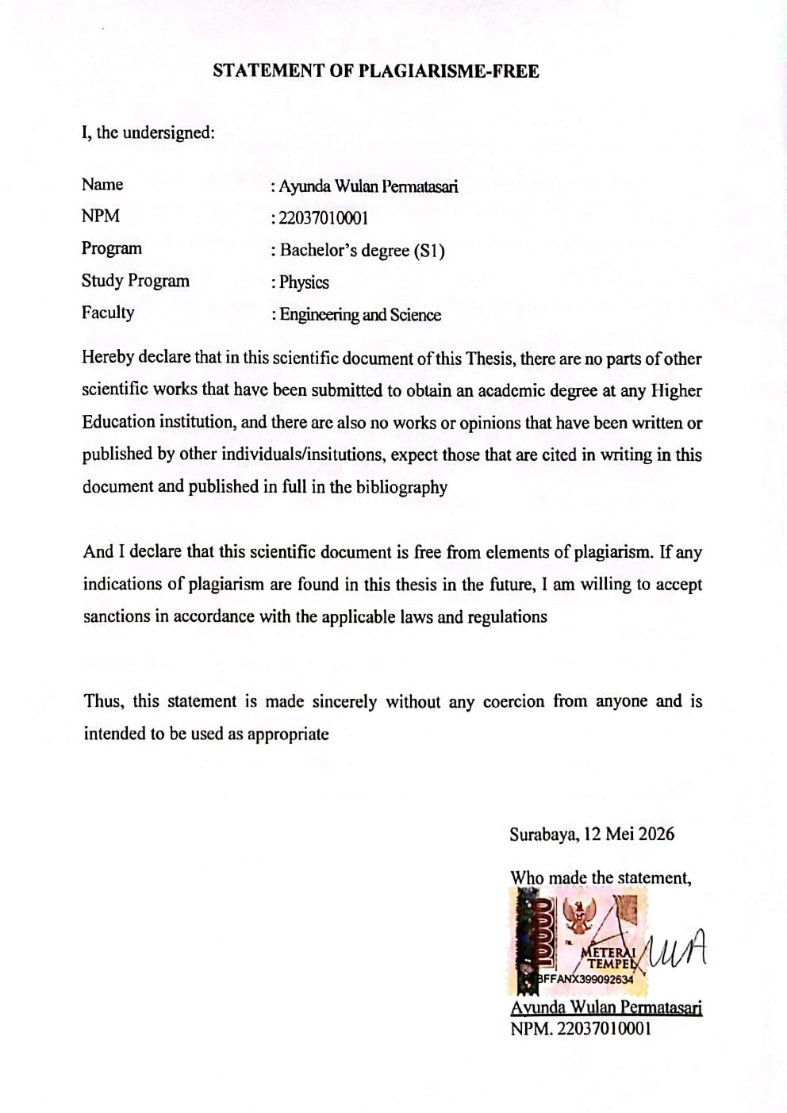

ABSTRACT

This study aims to investigate the effect of calcination and sintering temperatures on the structural and mechanical properties of PVA-Hydroxyapatite (HAp) bioceramics derived from chicken and duck eggshells. To improve its physical performance and broaden its applications, HAp can be combined with PolyVinyl Alcohol (PVA) as a polymer matrix. The HAp was synthesized using the wet chemical precipitation method followed by calcination and sintering processes at temperatures of 800°C, 900°C, and 1000°C. Characterization was carried out using XRD, FTIR, SEM and hardness testing using Shore A durometer. The results showed that hydroxyapatite was successfully synthesized from both chicken and duck eggshells, as confirmed by the characteristic XRD peaks and the presence of phosphate (PO³⁻) and hydroxyl (OH-) functional groups identified through FTIR analysis. Increasing calcination and sintering temperatures significantly improved crystallinity, phase purity, and particle homogeneity. At 800°C, a secondary whitelockite phase was still observed, wehereas at 900°C and 1000°C, single phase hydroxyapatite 100% purity was successfully formed. SEM analysis revealed a denser particle distribution at higher temperatures, with particke sizes ranging from 0-500 nm and a average particle size of approximately 254.619 nm. Mechanical testing showed that the chicken eggshell sample treated at 1000-800°C exhibited the highest hardness value of 4.715 MPa, while the duck eggshell sample treated at 900-1000°C exhibited the lowest hardness value of 3.095 MPa. The porosity observed in the bioceramic structure also influenced the resulting mechanical strength. Overall, this study demonstrates that hydroxyapatite derived from chicken and duck eggshell waste combined with PVA has promising potential for biomaterial applications.
4
Keywords: Hydroxyapatite, eggshell waste, PVA, bioceramics, calcination temperature, sintering temperature, biomaterials.

FOREWORD

All praise and gratitude are due to God Almighty for His abundant blessings and grace, which have enabled the author to complete this undergraduate thesis proposal entitled “Effect of Calcination and Sintering Temperatures on the Structural and Mechanical Properties of PVA–Hydroxyapatite Bioceramics Derived from Chicken and Duck Eggshells.” The preparation and writing of this thesis proposal could not have been accomplished properly without the assistance, support, and prayers of various parties.
The author wishes to express gratitude by thanking the people who helped in completing the preparation of this thesis:
- To Mr. Prof. Dr. Ir. Akhmad Fauzi, M.MT., IPU as Rector of the Universitas
Pembangunan Nasional “Veteran” Jawa Timur
- To Prof. Dr. Dra. Jariyah, M.P., Dean of the Faculty of Engineering and
Science, Universitas Pembangunan Nasional “Veteran” Jawa Timur.
- To. Dr. Dira Ernawati, S.T., M.T., as coordinator of the Physics Study
Program, Universitas Pembangunan Nasional “Veteran” Jawa Timur.
- To. Dr. Nur Aini Fauziyah, S.Pd., M.Si., as Thesis Supervisor 1, as the author’s intership supervisor and first thesis supervisor, the author would like to express sincere gratitude for the time, patience, attention, and valuable experience that she consistently provided despite her busy schedule. Every piece of advice, guidance, and motivation given by her has always been a source of encouragement for the author, not only during the process of writing this thesis but also as valuable preparation for entering the professional world and pursuing further studies.
- To. Dr. Nailul Hasan, S.Si., M.Sc., as Thesis Supervisor 2, as the author’s second thesis supervisor, the author would like to express sincere appreciation for the suggestions, time, and patience that he generously provided. Every piece of advice, direction, and knowledge shared by him has been highly beneficial to the author throughout the completion of this thesis.
- To. Dr. Allif Rosyidy Hilmi, S.Si., M.Si, the author would like to express sincere gratitude for the guidance, assistance, and willingness to help during

the preparation of this thesis, especially when the author encountered difficulties in data processing and analysis.
- To the author’s beloved parents, the author would like to express heartfelt gratitude for their prayers nd unwavering support in completing this thesis. In particular, the author would like to extend the deepest appreciation to the author’s mother for her endless prayers, care, affection, emotional and material support, as well as continuous motivation that enabled the author to complete this study with enthusiasm and determination. She has been the greatest source of strength and encouragement, inspiring the author to complete this academic journey successfully. Evert sacrifice, attention, and motivation given has become a source of strength for the author to complete this study ti the best of their ability.
- To my siblings, the author would like to express sincere gratitude for the prayers, support, motivation, and advice that have encouraged the author throughout the completion of this study. Their support and encoyragement have become a great source of motivation during the thesis-writing process, enabling the author to complete this study with pride and gratitude.
- To all my friends, the author would like to express sincere appreciation for the encouragement, support, enthusiasm, motivation, assistance, and friendship that they have provided throughout the author’s academic journey and during the completion of this thesis.
The author realizes that there are still shortcomings in the preparation of this thesis proposal. Therefore, constructive suggestions and criticisms are highly appreciated. Finally, the author hopes that this thesis proposal will be beneficial for the author and all relevant parties, especially Physics students in general.
Surabaya, 8 April 2026

Ayunda Wulan Permatasari

TABLE OF CONTENTS

APPROVAL PAGE ……………………………….ii

STATEMENT OF PLAGIARISME-FREE iii
ABSTRACT iv
FOREWORD v
TABLE OF CONTENTS vii
LIST OF TABLES ix
LIST OF FIGURES x
LIST OF APPENDICES xii
CHAPTER I 1
INTRODUCTION 1
  - Background 1
  - Problem Formulation 3
  - Research Objectives 3
  - Research Benefits 4
  - Hypotesis 4
CHAPTER II 5
LITERATURE REVIEW 5
  - Sources of Hydroxyapatite 5
  - Hydroxyapatite sintesis 7
  - Phases of HAp Formation 9
  - Ceramic Hydroxyapatite PolyVinyl Alcohol 15
  - Principles of operation of Characterization instruments 19
  - Previous Studies 24
CHAPTER III 26
RESEARCH METHODOLOGY 26
  - Research Approach 26
  - Research Variable 26
  - Hydroxyapatite (HAp) synthesis 27
    - The Experimental Procedure 27
    - Hydroxyapatite (HAp) Synthesis Process 28
    - Preparation of hydroxyapatite (HAp) ceramics 29
  - Characterized 29
CHAPTER IV 31
RESULTS AND DISCUSSION 31
  - XRD Analysis of CaCO3 Decomposition into CaO at Different Calcination Temperatures 31
  - XRD Analysis of Hydroxyapatite Formation at Different Calcination 36
  - SEM Characterization 44
  - FTIR Characterization 48
  - XRD Analysis of PVA-Hydroxyapatite Pellets 58
  - Shore A Hardmess Test Analysis of PVA-Hydroxyapatite Pellets 59
  - Structural study in relation to the mechanical hardness of hydroxyapatite. 62 CHAPTER V 66
CONCLUSION AND SUGGESTION 66
  - Conclusion 66
  - Suggestion 67
REFERENCES 68
APPENDIX 74

LIST OF TABLES

Table 1. Sources of Hydroxyapatite… 5
Table 2. Results Previous Studies. 24
Table 3. Research Variables 26
Table 4. Comparative results of initial calcination temperature on the decomposition of CaCO₃ into CaO 34
Table 5. Comparative results of second calcination temperature on the formation of pure hydroxyapatite 39
Table 6. Results of calcination induced changes in pure hydroxyapatite from
chicken eggshell 42
Table 7. Results of calcination induced changes in pure hydroxyapatite from duck
eggshell 43
Table 8. FTIR Functional Group Results… 51
Table 9. Results of Shore A Hardness Test Analysis… 59

LIST OF FIGURES
Figure 2.1 Crystal Structure of Hydroxyapatite (HAp) 7
Figure 2.2 Several Methods for HAp Formation with Calcination Temperature Variations 8
Figure 2.3 Diffraction Pattern of Hydroxyapatite Samples 9
Figure 2.4. Illustration of the Role Mg²⁺ in Bone 10
Figure 2.5. (a) Crystal Structure (b) Experimental Conditions Diagram 11
Figure 2.6. Modification of Phosphate Ion Vibrations 12
Figure 2.7. Whitlockite Synthesis Procedure 13
Figure 2.8. The Effect of PVA addition on the Density and Relative Density of Sintered HAp Bodies 16
Figure 2.9. Three-Dimensional Graph and Porosity of HAp Samples 17
Figure 2.10. XRD Analysis of HAp-PVA Composite 18
Figure 2.11. FTIR Analysis of HAp-PVA Composite 18
Figure 2.12. XRD Patterns Representing (a) Amorphous Material and (b) Crystalline Material 20
Figure 2.13. Principles of Operation FTIR 21
Figure 2.14. Principles of Operation SEM 22
Figure 2.15 Principles of Operation hardness shore A. 23
Figure 3.1 Synthesis of Hydroxyapatite. 27
Figure 3.2 Research Flowchart… 30
Figure 4.1. XRD Results at Different Temperatures Using the Same Material… 31
Figure 4.2. Graph of the Effect of Eggshell Source Type as CaCO₃-CaO… 32
Figure 4.3. Color Changes at Different Temperatures During the Calcination of CaCO₃ 35
Figure 4.4. Representative XRD Results of Hydroxyapatite 36
Figure 4.5 Effect Of Final Calcination Tempature on the Sample 37
Figure 4.6 Effect Of Final Calcination Temperature 800°C of HAp Procedure 38

Figure 4.7 Composition Chicken Eggshell and Duck Eggshell of
Hydroxyapatite… 41
Figure 4.8. SEM Analysis of Hydroxyapatite (HAp) with Different Variations and
Temperatures… 44
Figure 4.9. Representative of Particle Size and Morphological Characteristic of
Hydroxyapatite (HAp)… 46
Figure 4.10. Comparative FTIR Results of Duck Eggshell at Different Initial
Calcination Temperatures… 48
Figure 4.11 Comparative FTIR Results of Chicken Eggshell at Different Second
Calcination Temperature 48
Figure 4.12 Comparison of XRD Results of Pellets Before and After Furnace
Treatment… 58
Figure 4.13 Shore A hardness values of hydroxyapatite (HAp) pellets derived from
chicken and duck eggshells at different calcination temperatures… 60
Figure 4.14 SEM micrographs of PVA-HAp pellets 64

LIST OF APPENDICES
Appendix 1. Documentation of initial sample conversion to hydroxyapatite sample 74
Appendix 2. Matching Results of X-Ray Diffraction (XRD) results of CaO derived from duck and chicken eggshells. 76
Appendix 3. X-Ray Diffraction (XRD) results of hydroxyapatite derived from duck and chicken eggshells. 78
Appendix 4. SEM of Hydroxyapatite Powder Analysis 83
Appendix 5. (FTIR) analysis results of hydroxyapatite… 84
Appendix 6. Shore A hardness test analysis 85
Appendix 7. Biodata 100

